

Student Name: KABURU EVANS MUTHOMI
Admission Number: BSCCS/2024/62210
Course/Class: Bachelors of Science in Computer Science
Unit Code: BIT4138
Unit Name: Advanced Cryptography
Lecturer Name: Michael Nyoro
Semester/Academic Year: May/August 2026

GitHub Repository Link:
https://github.com/mthomikaburu

Contents
Week 7 3
Digital Signatures and Certificates 3
Fig 1: Digital Signature Generation 3
Fig 2: Signature Verification Process 4
Fig 3: Certificate Creation Using OpenSSL 4
Fig 4: Secure Document Validation 5
Fig 5: Certificate Testing Results 5
Student Reflection 5

Week 7

Digital Signatures and Certificates
Digital Signature Implementation and Certificate Management

Fig 1: Digital Signature Generation
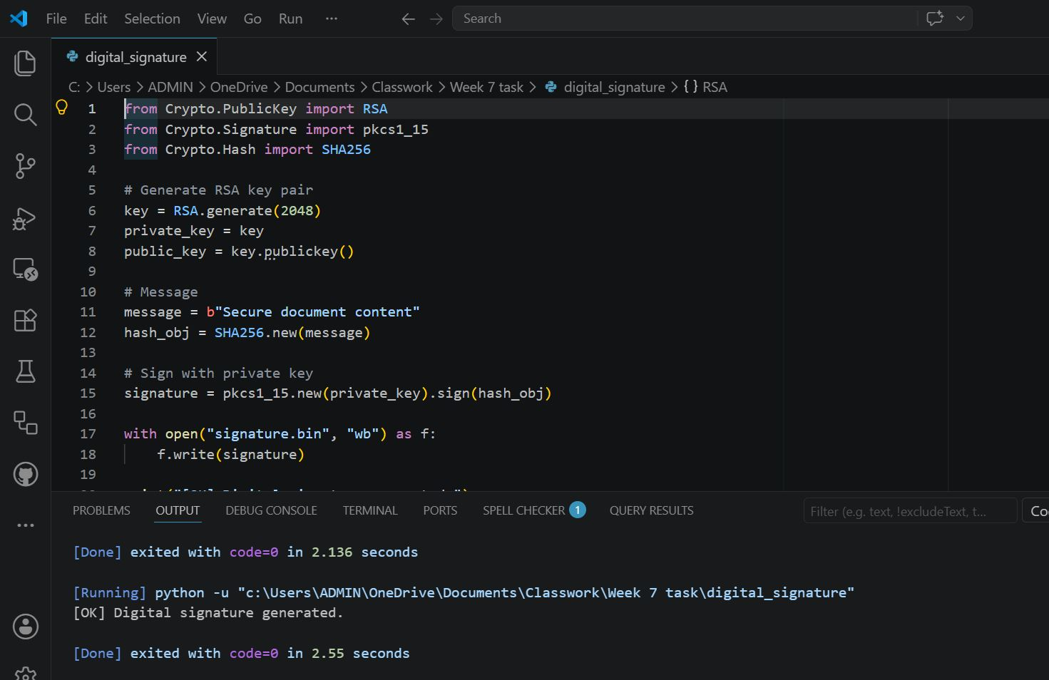

Fig 2: Signature Verification Process
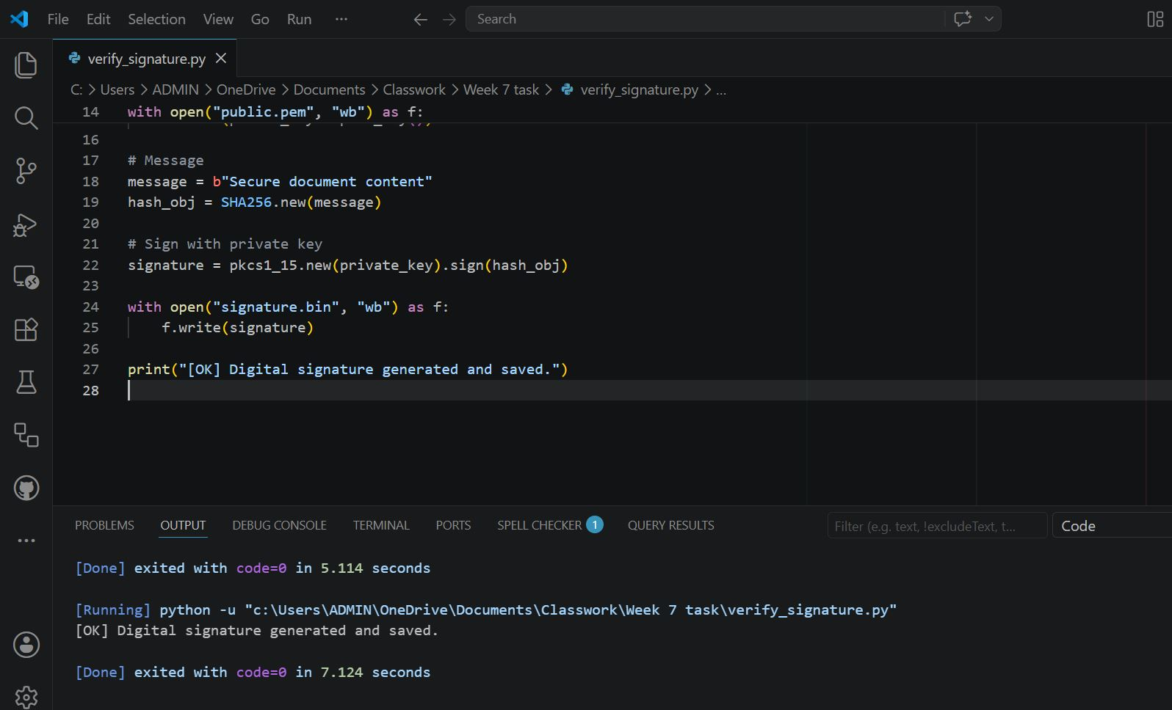

Fig 3: Certificate Creation Using OpenSSL
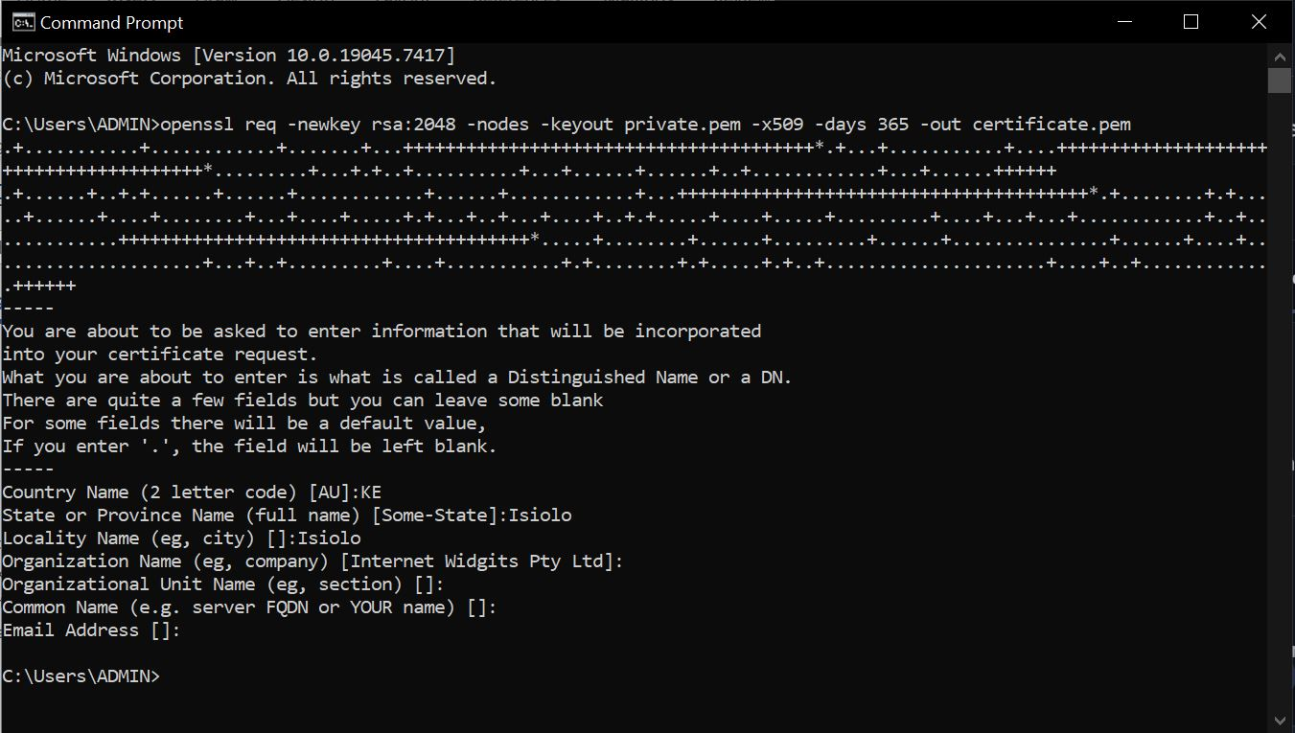

Fig 4: Secure Document Validation
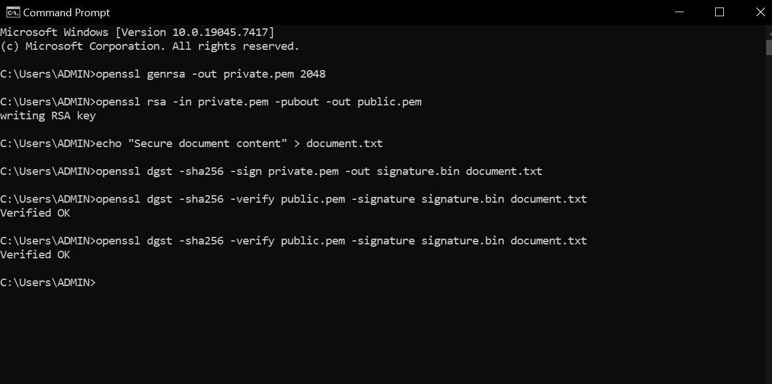

Fig 5: Certificate Testing Results

Successful verification

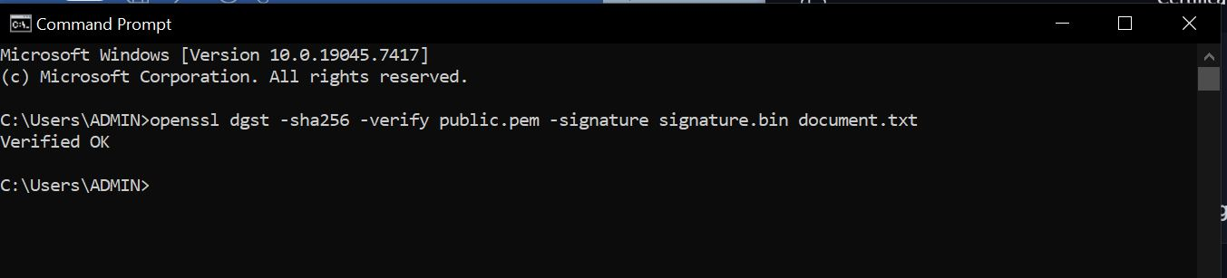

Failed verification

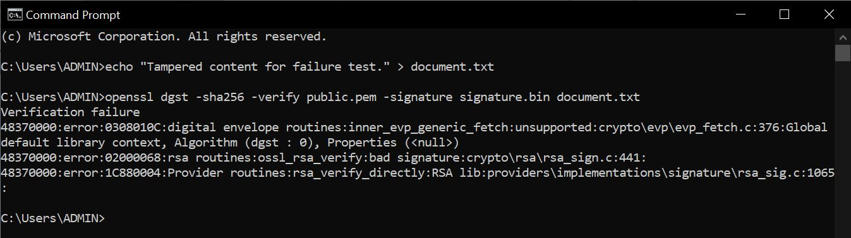

Student Reflection
Digital signatures ensure integrity and authenticity using asymmetric keys. Public keys verify signatures, private keys generate them. Certificates strengthen trust by binding identities. Testing confirmed signature generation, verification, and secure document validation, highlighting RSA’s role in certificate-based security.

